**NAME : M.K.I DE SILVA**

**INDEX NO : E1946316**

**SUB. DATE : 2023/06/10**

**ITE 2152 – MOBILE APPLICATION DEVELOPMENT**

**ASSIGNMENT 2**

**USER MANUAL OF NEWSPAPER STORE ANDROID APP**

**News Paper Store Android App User Manual & Documentation**

This news paper store app provides the delivery person to view the assigned trip details for the selected date. Trip details are taken from MySQL server using API. Driver can login to the system using his/her driver id which is the NIC number.

To run this application in your lap top, you should have

* Android studio
* Intelij IDEA/ eclipe IDE
* MySQL
* Internet connection

Before running this app in your laptop you should do following things.

* Put the IPv4 address in the mentioned line (line 38) in the given path.

Path from source root - com/example/assignment/retrofit/RetrofitService.java

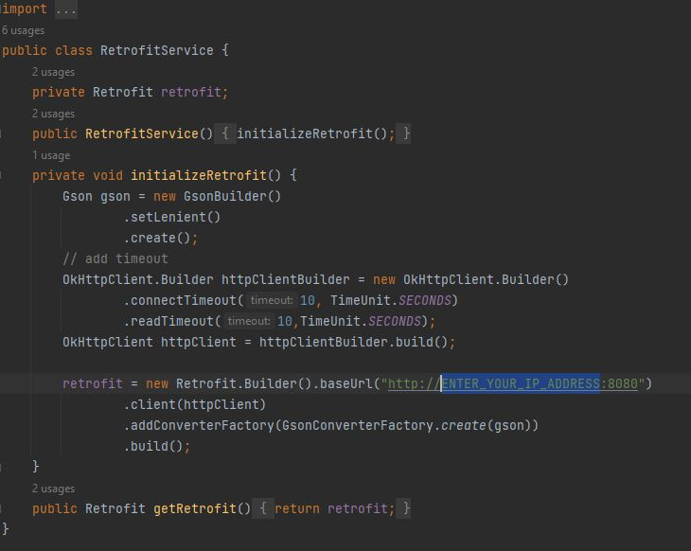

* Configure mysql using user name and password in mysql (src/main/resources/application.properties)
* First run the project named as “Assignment API” using Intelij IDEA/ eclipse ..etc. It is a spring boot web application.
* Then run the project named as “Assignment” using Android Studio. It is the code for mobile app.
* Add some data to the created tables in mysql.
* Then your app is setup for working. Loging page is loaded.

LOGIN PAGE

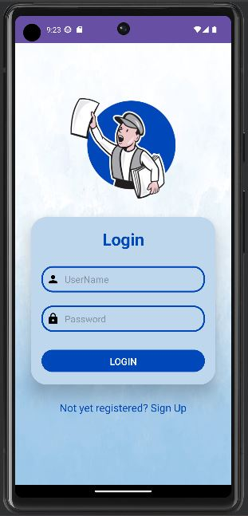

* Enter user id and password in the given text boxes and press enter.
* If password or user id is wrong, you will get error message

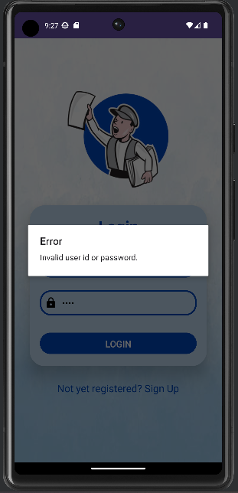

* If login is success, you are redirected to next page.

DASHBOARD PAGE

* You can select the date and click either list view or map view buttons.

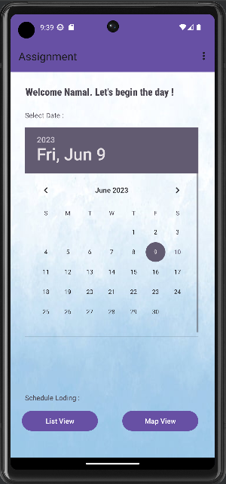

* You can view the schedule in list when you click the list view button which are assigned to the logged user id and selected date.

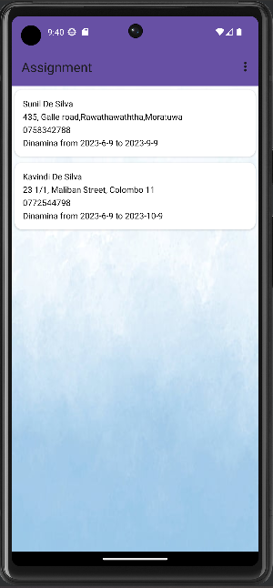

* You can logout or go to previous page by clicking the options in toolbar.

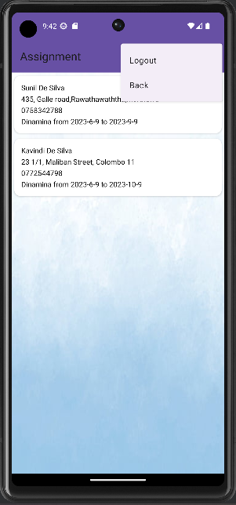

**APPENDIX**

**Use case diagram of the database**

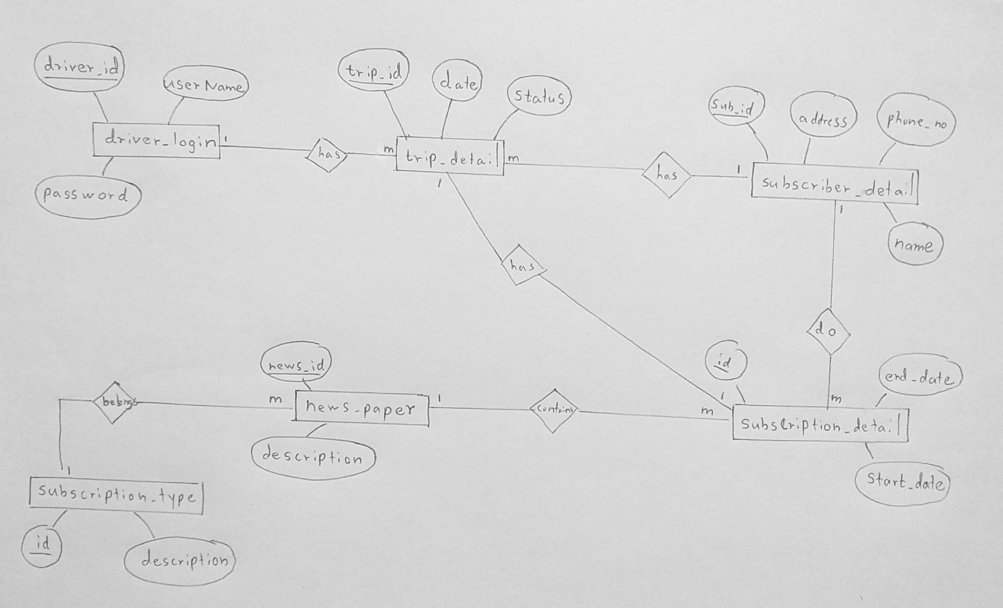

**ER diagram**

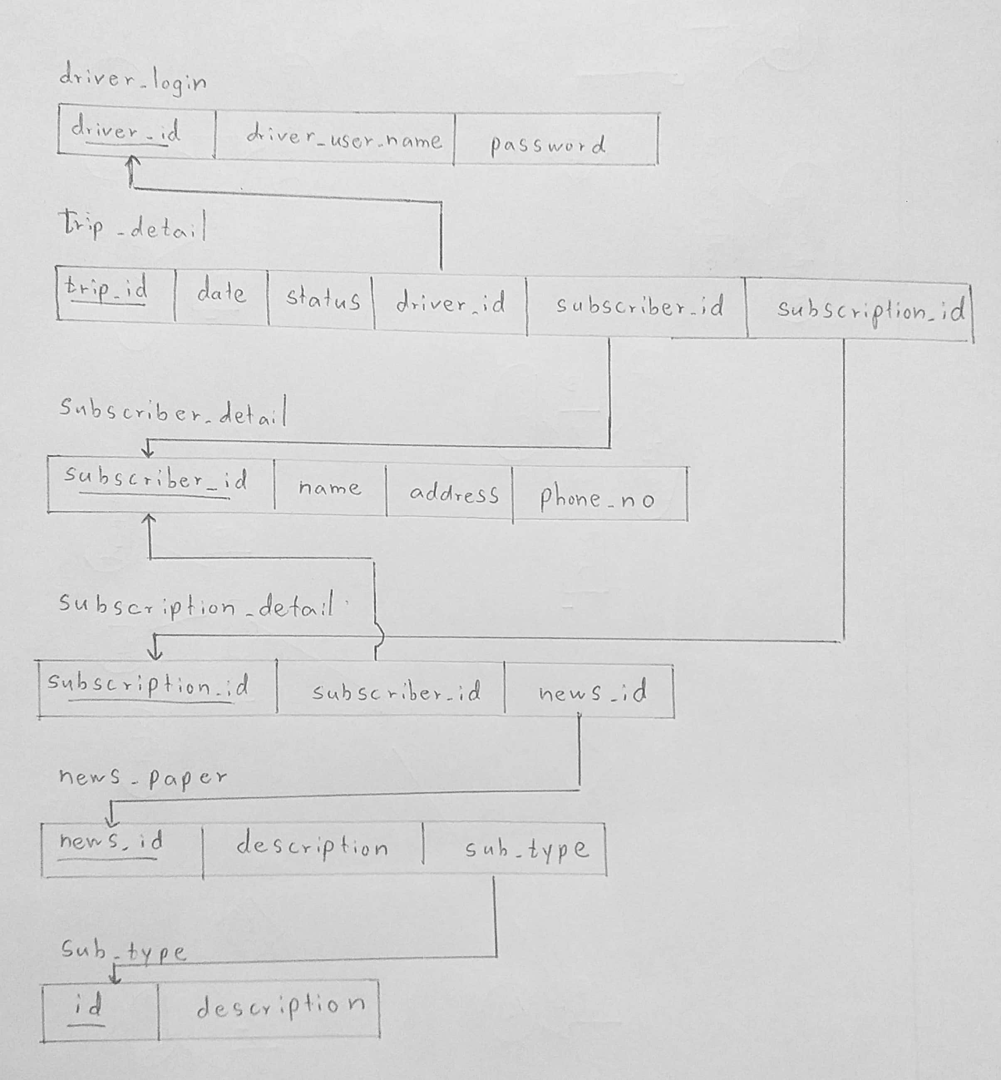

**Structure of the returned json object from API for the selected date and user id**

{

    "driverId": "2",

    "driverUserName": "Namal",

    "password": "1234",

    "tripDetails": [

        {

            "tripId": 2,

            "status": **null**,

            "date": "2023-6-9",

            "subscriberDetail": {

                "subscriberId": 2,

                "subscriberName": "Kavindi De Silva",

                "subscriberAddress": "23 1/1, Maliban Street, Colombo 11",

                "subscriberTel": "0772544798"

            },

            "subscriptionDetail": {

                "subscriptionId": 2,

                "startDate": "2023-6-9",

                "endDate": "2023-10-9",

                "newsPaper": {

                    "newsPaperId": 1,

                    "description": "Dinamina",

                    "subscriptionType": {

                        "subTypeId": 2,

                        "description": "weekly"

                    }

                }

            }

        },

        {

            "tripId": 3,

            "status": **null**,

            "date": "2023-6-9",

            "subscriberDetail": {

                "subscriberId": 1,

                "subscriberName": "Sunil De Silva",

                "subscriberAddress": "435, Galle road,Rawathawaththa,Moratuwa",

                "subscriberTel": "0758342788"

            },

            "subscriptionDetail": {

                "subscriptionId": 1,

                "startDate": "2023-6-9",

                "endDate": "2023-9-9",

                "newsPaper": {

                    "newsPaperId": 1,

                    "description": "Dinamina",

                    "subscriptionType": {

                        "subTypeId": 2,

                        "description": "weekly"

                    }

                }

            }

        }

    ]

}

* API end points are tested using Postman
* Driver link for demonstration video and the codes
  + <https://drive.google.com/drive/folders/1Ac2dUO8gzQ7XBEbs1nTS8CrSEi0iHUwF?usp=sharing>